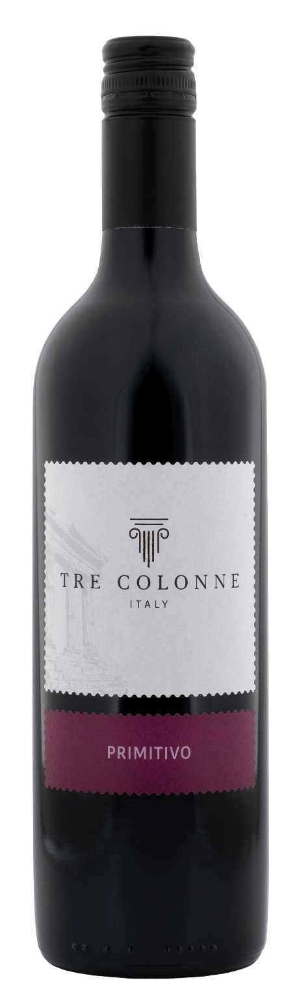
PRIMITIVO PUGLIA IGP – TRE COLONNE

Grape: Primitivo 100%
Alc. Vol.%: 13
Vintage: 2024
Residual sugar g/l: 6,0
Total acidity g/l: 5,4
Region: Apulia
Capacity: 750ml

CHARACTERISTICS

Vinification: Once the fermentation is over the wine ages in steel tanks until bottling
Aging: In steel tanks until bottling
Yield per ha: 14000kg
Colour: Intense bright red
Bouquet: Notes of red berries
Flavour: Fruity and intense

SERVING SUGGESTIONS

Best enjoyed with starters and savoury first courses.
Serving temperature 16-18 °C
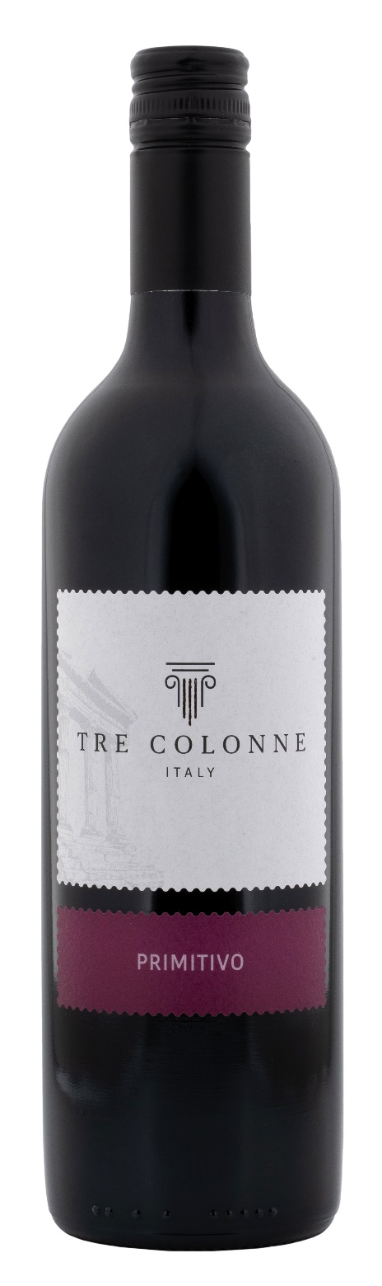
TECHNICAL INFORMATION / PALLETIZING

Size 750ml:
Article Nr. V140028A
GTIN-13 bottle 8017868006459
GTIN-13 carton 8017868004950
Closure Cork/Screwcap
Bottles / carton 6 bottles
Pallet size 80x120cm
Cartons/layer 25
Cartons/pallet 125
Kg/carton 7,0
Kg/pallet 892

Contains sulphites
GMO Free
Revisione 01. 14.05.2026

